
September 2025
Our monthly newsletter is designed to keep you up to date with the latest cancer events, updates and projects happening throughout the West Midlands. Please feel free to share this newsletter within your teams. If you would like to submit an article for a future newsletter, please contact:
rwh-tr.wmcacomms@nhs.net.

In this edition:  - Best Practice Birmingham and Respiratory Professional Care 2025  - Skin Cancer Awareness Day – Kingswinford & Wordsley PCN  - Cancer Academy informal drop-in sessions  - Visit to Buckingham Palace by Janette Rawlinson, Patient Advocate, Lung Expert Advisory Group (EAG)  - Clinical Cabinet documents  - New dates launched for PCCP course | - Stoptober 2025  - Upcoming Expert Advisory Group (EAG) meetings  - UK Oesophago-Gastric Cancer Pathway Event, Tuesday 25 November 2025, Manchester  - Check out our new Cancer Academy  - WMCA Expert Advisory Group (EAG) recruitment  - LGBTIQ+ Patient Advocate recruitment  - PI3K Colorectal Cancer
In the spotlight
Best Practice Birmingham & Respiratory Professional Care 2025  The West Midlands Cancer Alliance (WMCA) will be exhibiting at Best Practice Birmingham & Respiratory Professional Care 2025 - the UK’s leading event for primary and respiratory care professionals, taking place Wednesday 8th and Thursday 9th October at the NEC, Birmingham.  Best Practice Birmingham brings together the Primary Care community for learning, collaboration, and innovation across two days. The event is designed to highlight the latest developments in General Practice and features expert-led seminars, interactive workshops, and exhibitions. It is an event for GP’s, practice managers and the wider primary care teams and offers a valuable networking experience as well as an opportunity to shape the future of General Practice.  Should you wish to register to attend Best Practice Birmingham, please click here.  To view the conference programme, please click here.  To see all the exhibitors at this year’s event, please click Best Practice Birmingham Exhibition & Conference | NEC Birmingham  We are delighted that WMCA stand will have representatives from the Primary Care and Early Diagnosis team, to highlight current work and future opportunities in cancer care in the West Midlands. We will be showcasing work including Lung Cancer Screening, FIT testing, workforce and training support and resources, and plenty more. The WMCA will also be launching additional content onto the WMCA Cancer Academy web pages, specifically designed for Primary Care colleagues.  Karen Lees Programme Manager – Primary Care Pathways, West Midlands Cancer Alliance said “We’re thrilled to have a stand at Best Practice Birmingham in October for the very first time. This will give us a fantastic opportunity to meet colleagues from across primary care, share the work of the West Midlands Cancer Alliance, and explore how we can work together to improve earlier cancer diagnosis and outcomes for patients. We look forward to connecting with as many of you as possible over the two days”  Dr Sonia Ashraf, Deputy Clinical Director, West Midlands Cancer Alliance commented “It is fantastic to have the Cancer Alliance team at Best practice, to equip primary care clinicians with the knowledge and skills they can acquire through the wealth of information on the West Midlands Cancer Alliance website for them and their patients regarding cancer and through the regular educational events, cancer updates and outcomes from our expert advisory groups for each tumour type.”  Please pop along to see us at our stand RE02 – we would love to meet you and hear your thoughts!  To find out more information on the work of the WMCA in Primary Care,  please click https://wmcanceralliance.nhs.uk/professionals-area/clinical-resources/primary-care-resources | 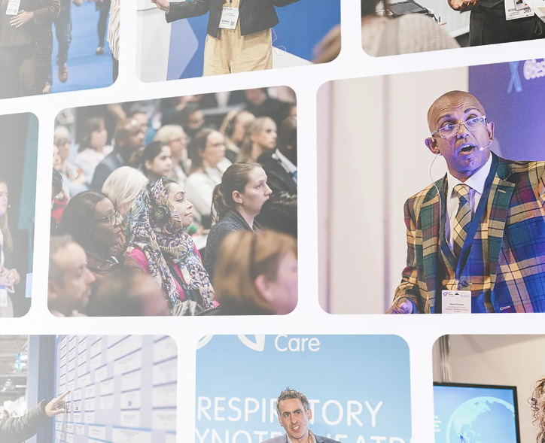
Latest news

Skin Cancer Awareness Day – Kingswinford & Wordsley PCN  On Saturday 16th August, Kingswinford & Wordsley PCN held a highly successful Skin Cancer Awareness Day at Wordsley Community Centre. The event was organised by Rajvinder Mann and Sarah Baig, with support from Consultant Dermatologists Dr Peng, Dr Bandara and Dr Baggan (Dudley Group NHS Foundation Trust), BCICB Cancer Services, the Patient Participation Group (PPG), pharmacy students, Your Health Dudley, and Prostate Cancer UK. Around 400 patients engaged throughout the day.  Key Activities  - Education sessions (9:30–10:00 & 11:00–11:30): Prevention-focused talks with Q&A on early signs, sun safety, and early detection.  - Patient consultations: 45 one-to-one mole checks using dermatoscope’s at Wordsley Green Health Centre; onward referral advice given where appropriate.  - Information & support stalls: BCICB Cancer Services, PPG, pharmacy students, Your Health Dudley, and Prostate Cancer UK provided resources and interactive discussions.  - Health checks: Free blood pressure checks offered alongside lifestyle advice.  - Patient flow & welcome: PPG members/volunteers managed registration and escorting.  Outcomes  - 400+ attendees across talks, stalls, and consultations.  - 45 specialist mole checks completed with clear next-step guidance.  - Strengthened community engagement and improved awareness of prevention and early detection.  This event showcased the impact of collaboration across primary care, specialist services, charities, students and volunteers to empower our community to act early on skin health. | 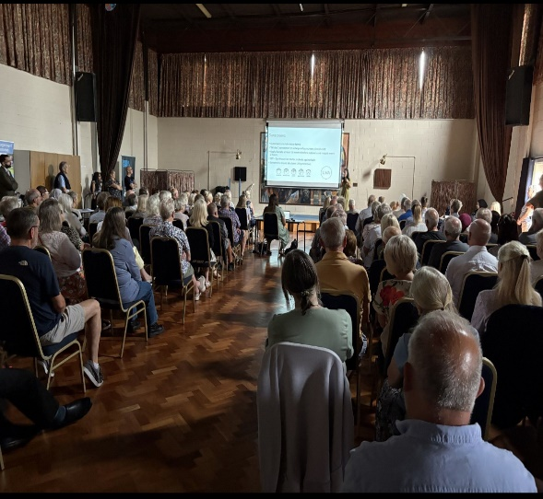

Cancer Academy informal drop-in sessions
The West Midlands Cancer Alliance Workforce team are pleased to offer informal drop-in sessions to support staff in using the ePortfolio. Whether you're just getting started or have specific questions, we’re here to help.
Feel free to attend with any queries about the ePortfolio or any aspect of the Cancer Academy. It’s a great opportunity to learn more, get hands-on guidance, and connect with the team.
The first session is scheduled for Monday 29th September with more dates to follow.
Please use this MS link on Wednesday 8th October 11-1pm
Please use this MS link on Thursday 23rd October 1-3pm
We look forward to seeing you there!
Visit to Buckingham Palace by Janette Rawlinson, Patient Advocate, Lung Expert Advisory Group (EAG)  Sometimes in life, we have those ‘pinch me’ moments when events feel rather surreal. Amazingly I had several of those recently.  Having been part of Roy Castle Lung Cancer Foundation patient literature review panel since 2011, part of their lung screening advisory group then NHSE lung screening group, advocate member of the LC CEG (for which they provide secretariat) and various other roles and work to support lung cancer, it was with bemusement that I received an invitation from their CEO, Paula Chadwick to attend Buckingham Palace on 30th April. Was it a garden party or something else? What would I wear? Who else would be going?  Thrilled at the prospect (my late mum was a Royalist), more details emerged – this was to a community-based cancer support reception at the Palace to mark the 1-year anniversary of the King returning to work after his cancer treatment.  The charity had invited 8 people – 2 patients, 2 carers, 2 staff members and 2 lung clinical nurse specialists. We met near St James Palace and approached the palace together. No phones allowed inside the building itself keeps photos from circulating on social media and an official photographer and national press were attending we learnt on the night.  A choir of breast cancer patients fronted by Lorraine Kelly greeted us when we arrived in the main area, then the King and Queen made their entrance and split up working the room in different parts. Camilla in a wing with Debra James’ parents, and other celebrities as I saw in national news coverage that night with other celebrities involved with cancer also at the event including Victoria Derbyshire, Ashley Caine, Giovanni from Strictly, Emma Willis, Adele Roberts, and others. They with the Duchess of Gloucester and Sarah Ferguson circulated the room. We were some of the last to leave with the Royals leaving just after 8pm, having got to know the group and chatted with Royal Household members and others. Staff explained this was a very personal cause for the King and he’d invited many community-based cancer charities to nominate people for the unique reception.  The next day I’d been invited by my surgeon to speak at an industry event at Heathrow Airport for the multinational company he’s now at, explaining my story to 600 delegates! Sitting in the green room with company staff, the familiar looking chap arriving after lunch was Tim Peake, astronaut, their keynote speaker!  About a month later, I received another invitation from the charity to join them at no 10 Downing Street to celebrate their 35th anniversary with a meeting on 25th June with the parliamentary under-secretary for public health and prevention. They’d invited many of those involved over many years to introduce and rollout lung screening for the UK and when it emerged that future funding maybe in question, it took a different slant with attendees speaking about the progress made in lung cancer diagnostics, treatments and prevention and make the case for continued funding. With brief speeches from Karin Smyth MP, Paula Chadwick, Prof David Baldwin and a patient recently diagnosed with a stage 1 lung cancer, successfully operated on as a result of screening and now climbing glaciers and thankful for being detected early, the case sounded even more compelling.  It was really an event full of so many experts and dedicated healthcare professionals united in trying to improve lung cancer outcomes over their careers – many of whom I know from various different committees, studies and meetings. What an honour!  Reconnecting with many colleagues, friends and new connections made over the years during my involvement including those from the screening programme often only seen online, it was humbling and a privilege to be part of such events.  On a practical level, both old buildings were really not set up for 2 of the hottest days of the year – so not the most comfortable experiences but awesome, unforgettable and a wonderful experience, nonetheless! | 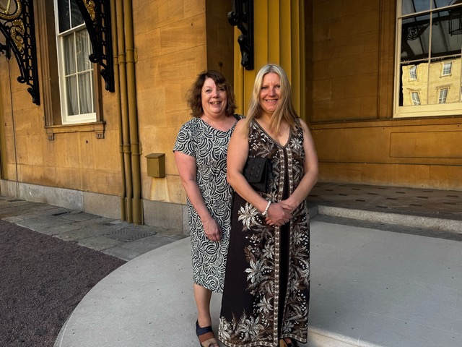  
Clinical Cabinet documents  The following documents were recently ratified at our September Clinical Cabinet and will be available on the website shortly.  - SACT Spillage Guideline v 5.0 Sept 2025  - Pregnancy testing for adults receiving SACT, v1.0 September 2025  - Cancer Multidisciplinary Meeting Best Practice Standardisation Guidance  - Multidisciplinary Team (MDT) Lead Job Description | 
What’s happening?

New dates launched for PCCP course
We are pleased to advise that new dates have been launched for the fully funded PCCP course, for Cancer Support Workers, who are working with people that are affected by cancer or may have a potential cancer diagnosis.

These places are only funded for unregistered Cancer Support Workers, who must have study leave approval for the 4 consecutive days, from their manager, before securing a place.

Please visit the site or signpost colleagues to book via the link below. Candidates will need to register if not already registered.

What's On: Cheshire & Merseyside Cancer Academy

16th Oct-22nd Oct (Thur, Fri, Tue, Wed)
30th Oct-5th Nov (Thur, Fri, Tue, Wed)
6th Nov-11th Nov (Thur, Fri, Mon, Tue)
27th Nov-3rd Dec (Thur, Fri, Tue, Wed)
4th Dec-9th Dec (Thur, Fri, Mon, Tue)

Stoptober 2025  Stoptober is back with a new suite of resources to encourage smokers to make a quit attempt this October!  With a whole calendar of both 'ready to use' and localisable resources, you will have the means to tailor this campaign to your specific audiences. The campaign is running until 31 October and all assets can be accessed here. | 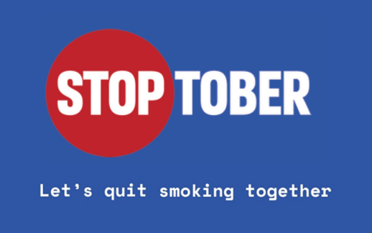
Upcoming events

Upcoming Expert Advisory Group (EAG) meetings  Expert Advisory Groups (EAGs) provide specialist advice and guidance to the WMCA board on the standards of cancer care for patient, reflecting ‘Improving Outcomes Guidance’ recommendations, current best practice and opportunities for development.  Details of upcoming EAG meetings:  Please note that these meetings are for EAG Members only.  For more information about joining these meetings, please email:  rwh-tr.wmcanceralliance@nhs.net.  *Please note that dates are correct at time of publication | 
  7th October 2025 | MSCC AO & CUP EAG
  9th October 2025 | Gynaecology EAG
  14th October 2025 | Lung EAG
  3rd November 2025 | SACT EAG
  6th November 2025 | HPB EAG
  12th November 2025 | Primary Care EAG
  21st November 2025 | Head and Neck EAG
  26th November 2025 | Haematology EAG
  27th November 2025 | Psychosocial EAG
  27th November 2025 | Skin EAG
  27th November 2025 | Sarcoma EAG
UK Oesophago-Gastric Cancer Pathway Event, Tuesday 25 November 2025, Manchester  This free national event is an opportunity to bring together leaders from across the country to share best practice in Oesophago-Gastric cancer care and tackle unwarranted variation. Attendees will explore current practices nationwide, celebrate and showcase success stories in OG pathways, and work together to shape optimal pathways and a shared vision for the future. Suitable for: Cancer Alliance senior leaders, lead clinicians and the wider OG workforce  Click here to Register:  https://www.gmcanceracademy.org.uk/event/national-og-event/ | 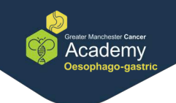
Development opportunities and additional learning

Check out our new Cancer Academy  Our Cancer Academy is a centralised platform designed to support lifelong learning for our current, and future, cancer workforce. Designed for our entire cancer workforce, our courses and extensive resources are aimed at enhancing your knowledge and helping you stay skilled and up to date in all thing’s cancer care.  Upcoming training can be found here. | 
Vacancies

WMCA Expert Advisory Group (EAG) recruitment:
The West Midlands Cancer Alliance are currently recruiting to vacancies for a number of Expert Advisory Groups (EAG’s).

See the full list of vacancies here.

- Head and Neck EAG Deputy Chair
- Gynaecology EAG Deputy Chair
- Colorectal EAG Deputy Chair
- Haematology EAG Deputy Chair

We are looking for candidates based on the following criteria:
- Ability to deliver national and regional work programme obligations.
- Demonstrable collaborative working with West Midlands Cancer Alliance.
- Experience with service change at scale.
- Credibility as a Cancer specialist in the West Midlands region.
- Regular attendance at EAGs or member of a Task and Finish group.
- Must be a current member of the West Midlands EAG group.

Candidates are asked to send their expressions of interest forms via email with accompanying CVs, stating why you would like to apply for this post, what you can bring to the post and your relevant experience for the role of Chair / Deputy Chair for the EAG to the following email: angela.gould1@nhs.net.

LGBTIQ+ Patient Advocate recruitment  The West Midlands Cancer Alliance (WMCA) are looking for LGBTIQ+ identifying patients who have lived experience of a cancer journey to join our expanding group of patient advocates. This could be their own experience of cancer or being there for a friend or a loved one on their cancer journey. A patient advocate participates in one of our cancer site Expert Advisory Groups (EAGs) and will be asked to express their views and opinions to help change, improve and shape the future of cancer care for the patient population of the West Midlands.  If you have any patients who may be interested in becoming a patient advocate or would like to find out further information, please contact the WMCA on rwh-tr.wmcapmo@nhs.net. | 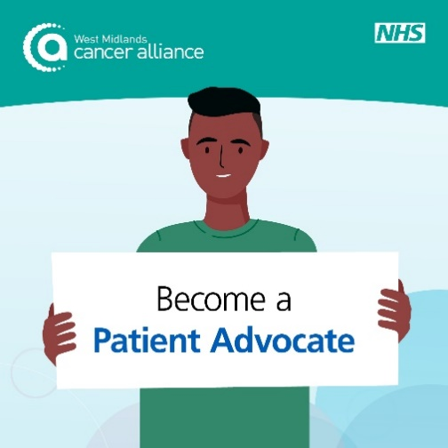
Primary Care update

PI3K Colorectal Cancer
What is the significance of PIK3 mutations and benefit of aspirin therapy in preventing recurrence of colorectal cancer?

What is PI3K?
PI3K and colorectal cancer
- PI3Ks belong to a family of plasma membrane-associated lipid kinases that can phosphorylate the 3′ hydroxyl group of phosphatidylinositol and phosphoinositide (1):
  - are divided into three classes, I, II, and III, based on their structures and functions
  - class IA PI3Ks, which are activated by receptor tyrosine kinases (RTKs), G protein-coupled receptors (GPCRs), and certain oncoproteins such as the small G-protein rat sarcoma virus (RAS), and class IB PI3Ks, are regulated exclusively by GPCRs
  - class I PI3Ks are the best characterized and generally coupled to extracellular stimuli
  - class 1A PI3Ks are divided into three subclasses (α, β, and δ), and class 1B is denoted as γ
    - PI3Kα and PI3Kβ are ubiquitously expressed, and PI3Kδ and PI3Kγ are mainly found in leucocytes and blood vessels
  - class IA PI3Ks have been reported to be implicated in human cancer
  - aberrant PI3K/Akt/mTOR signalling pathway is a major resistance mechanism to colorectal cancer therapy

Observational studies suggest that aspirin may improve disease-free survival after colorectal cancer diagnosis, particularly among patients with tumours harbouring somatic PIK3CA mutations (2).

A study investigated the use of aspirin in colorectal cancer patients with prespecified PIK3CA hotspot mutations in exon 9 or 20 (group A alterations) and those with other moderate- or high-impact somatic variants in PIK3CA, PIK3R1, or PTEN (group B alterations) (2):
- a double-blind, randomized, placebo-controlled trial involving patients with stage I, II, or III rectal cancer or stage II or III colon cancer with somatic alterations in PI3K pathway genes
- patients were assigned in a 1:1 ratio to receive 160 mg of aspirin or matched placebo once daily for 3 years
- primary end point was colorectal cancer recurrence
- alterations in PI3K pathway genes were detected in 1103 of 2980 patients (37.0%) with complete genomic data
  - of 515 patients with group A alterations and 588 patients with group B alterations, 314 and 312, respectively, were assigned to receive aspirin or placebo
  - estimated 3-year cumulative incidence of recurrence was 7.7% with aspirin and 14.1% with placebo (hazard ratio, 0.49) among patients with group A alterations and 7.7% and 16.8%, respectively (hazard ratio, 0.42) among those with group B alterations
  - estimated 3-year disease-free survival was 88.5% with aspirin and 81.4% with placebo among patients with group A alterations and 89.1% and 78.7%, respectively, among those with group B alterations
- study authors concluded that
  - aspirin led to a significantly lower incidence of colorectal cancer recurrence than placebo among patients with PIK3CA hotspot mutations in exon 9 or 20 and appeared to have a similar benefit among those with other somatic alterations in PI3K pathway genes

Reference:
- Leiphrakpam PD, Are C. PI3K/Akt/mTOR Signaling Pathway as a Target for Colorectal Cancer Treatment. Int J Mol Sci. 2024 Mar 9;25(6):3178.
- Martling A et al. Low-Dose Aspirin for PI3K-Altered Localized Colorectal Cancer. N Engl J Med 2025;393:1051-1064

External newsletters

Please find a list of external newsletters you may be interested in accessing:
- Read the latest East Midlands Cancer Alliance (EMCA) newsletter here
- Read the West Midlands Imaging Network’s weekly round up here
- Read the Central and South Genomics newsletter here
- Request to join the Midlands Outpatient Transformation Programme workspace here
- Sign up to the West Midlands Radiotherapy Network’s quarterly newsletter here
- Sign up to Cancer Research UK’s Health Systems email updates here.

