
October 2025
Our monthly newsletter is designed to keep you up to date with the latest cancer events, updates and projects happening throughout the West Midlands. Please feel free to share this newsletter within your teams. If you would like to submit an article for a future newsletter, please contact angela.gould1@nhs.net.

In this edition:  - Royal Orthopaedic Hospital Leads National Trial on Radiotherapy After Pathological Fracture Surgery  - West Midlands Cancer Alliance celebrates success of Lung Health Check Programme in Sandwell  - Shaping the Future of Cancer Care  - Best Practice Show  - Midlands Cancer Alliance Partnership Hub  - Participants in NHSE MDT Improvement Programme (cohort 2)  - Standing Firm in Power and Pride  - Black History Month Campaign Overview  - West Midlands Teenage and Young Adults Cancer Research Project  - CRUK Health System Update | - Cervical Screening Primary care good practice guide  - Upcoming Expert Advisory Group (EAG) meetings  - Event for Cancer and Pain Professionals  - Check out our Cancer Academy  - National Armed Forces Training  - WMCA Expert Advisory Group (EAG) recruitment  - Readers Panel recruitment  - Patient and public voice (PPV) partner roles  - Primary Care update  - External newsletters
In the spotlight
Royal Orthopaedic Hospital Leads National Trial on Radiotherapy After Pathological Fracture Surgery  Consultants at the Royal Orthopaedic Hospital in Birmingham are starting a new clinical trial that explores whether there is a need for radiotherapy following surgery for pathological fractures on metastatic bone cancer patients.  Approximately 70% of people with advanced breast and prostate cancer develop secondary bone cancer (metastases).  The disease weakens the bone, causing fractures which require surgery.  Following surgery for these fractures, patients usually receive radiotherapy. Despite its widespread use, there is no high-quality evidence that having radiotherapy after surgery improves pain, quality of life, or reduces the risk of needing another operation. Because radiotherapy has side-effects, as well as requiring additional hospital visits and scans, it is essential to understand if any benefits justify additional harms and cost  The study is supported by a £2.2m NIHR fund and will involve over 20 sites across the UK.  The trial team is seeking new centres to join - please email ytu-portrait@york.ac.uk for more information or if you have any queries.  For further detail on the clinical trial visit Portrait - Health Sciences, University of York |  | 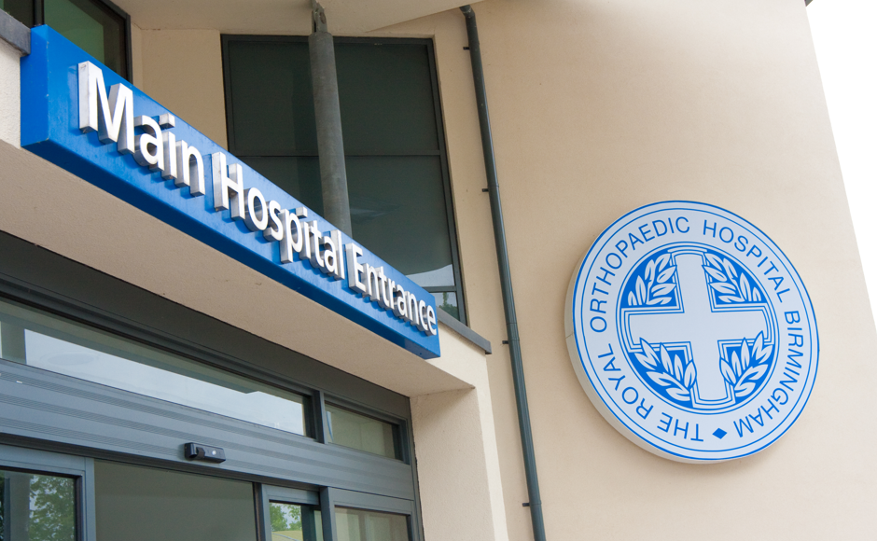  
Latest news

West Midlands Cancer Alliance celebrates success of Lung Health Check Programme in Sandwell  The West Midlands Cancer Alliance is proud to highlight the continued success of the Targeted Lung Health Check Programme in Sandwell, which is making a real difference in the early diagnosis of lung cancer for local residents.  Across the West Midlands, five Lung Health Check programmes are now live — covering Staffordshire & Stoke-on-Trent, Birmingham & Solihull, Sandwell, Dudley, and Coventry & Rugby and North Warwickshire.  Launched 18 months ago, the Sandwell programme has already identified around 6,200 people at high risk of developing lung cancer. To date, 41 people have been diagnosed with early-stage (stage 1 or 2) lung cancer, giving them the best possible chance of successful treatment.  One of those to benefit from the programme is 69-year-old Noel Cunningham from Great Barr. Noel quit smoking in 2017 after suffering a heart attack. Following a bout of COVID-19 and persistent ill health, his GP referred him for a lung health check, where a scan detected stage 3A cancer in his right lung and thoracic lymph nodes.  Noel said:  “If I hadn’t been sent for this screening, I would have been none the wiser. It’s been a bit of a journey, but I’ve had a lot of fantastic people take care of me, and I’m so grateful to the lung cancer screening team.”  The West Midlands Cancer Alliance continues to work closely with NHS partners to expand access to lung health checks, helping more people receive an earlier diagnosis and life-saving treatment.  For more information please visit - Cancer screening programme improves early diagnosis | Sandwell and West Birmingham NHS Trust |  | 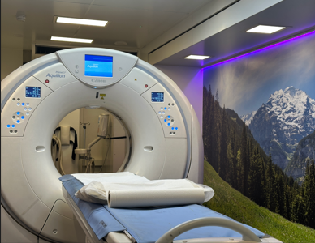
Shaping the Future of Cancer Care  Sarah Hughes, Managing Director at West Midlands Cancer Alliance, attended the Cancer Care Conference, taking part in a dynamic panel discussion on implementing the forthcoming Cancer Plan.  Sarah was honoured to be part of the panel for a lively and insightful conversation.  Key themes included:  💻 Maximising AI and digital opportunities while maintaining a focus on the basics in cancer care.  🏥 Collaboration across boundaries to improve outcomes.  💉 Ongoing innovation, such as progress in cancer vaccines.  The session reflected a strong shared commitment to advancing and adapting cancer care for patients  . |  | 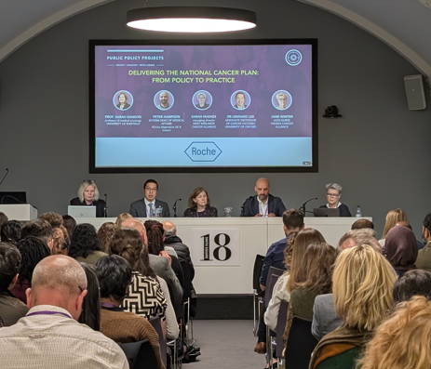
Best Practice Show  The West Midlands Cancer Alliance (WMCA) exhibited for the first time this year at Best Practice Birmingham & Respiratory Professional Care 2025 - the UK’s leading event for primary and respiratory care professionals, taking place Wednesday 8th and Thursday 9th October at the NEC, Birmingham.  Colleagues from our Early Diagnosis team had a stand to showcase the work of WMCA within the Primary Care sector. Led by Jacqui Morgan, Project Improvement Manager for Primary Care Pathways, alongside Karen Lees, Programme Manager for Primary Care Pathways and Emily Taylor-Page, Project Support Officer for Early Diagnosis. We were also supported on day one by Harvir Singh, Senior Programme Manager for Early Diagnosis, Dr Rajib Pal from Birmingham and Solihull ICB who works as a GP Cancer Lead at the Alliance and Dr Jim McMorran from Coventry and Warwickshire ICB who is the Alliance’s Primary Care Cancer Lead.  Some of the work showcased included the WMCA website and Primary Care resources page, Primary Care Programme Pilot, Lung Cancer Screening Incidental Findings, the Cancer Academy, Health Inequalities, and the next GP Educational Webinar on Haematology.  The show was very well attended by those working in the West Midlands and beyond across a broad range of job roles. The knowledge, passion, and expertise of those the team spoke with was palpable. We spoke with over 200 colleagues over the two days and not only gained valuable insight into areas we can improve but showcased the WMCA and the work we have done so far and increased our reach to a wider network.  The month of Best Practice saw the largest increase in followers on X versus any of the last 12 months and LinkedIn also saw a 25% increase in followers over the last 30 days. Additionally, the WMCA saw a four-fold increase in website traffic to the Primary Care Resources page across the 8th/9th/10th of October versus the same days of the previous six-weeks combined.  The team would like to thank all those who stopped to say hello, share their thoughts and ideas and we look forward to continuing to work alongside and support Primary Care teams across our region. The WMCA would also like to extend a special thanks to the following colleagues we work with who spoke at the show this year:  Mr. Janos Balega, Consultant Gynaecologist, Sandwell and West Birmingham Hospital - provided an update on ovarian cancer.  Dr. Shyam Menon, Consultant Gastroenterologist, University Hospitals Birmingham - provided an update on pancreatic and liver cancers.  Ms. Somiah Siddiq, Head and Neck Surgeon, University Hospitals Birmingham - provided an update on head and neck cancers.  Ms. Smruta Shanbhag, Consultant Gynaecologist and Gynae-Oncologist, University Hospitals Coventry and Warwickshire – provided an update on endometrial cancer and unscheduled bleeding on the HRT pathway.  Finally, we would like to thank our Deputy Clinical Director, Dr Sonia Ashraf, who chaired a clinical theatre on Wednesday and came to support the stand during her breaks. |  | 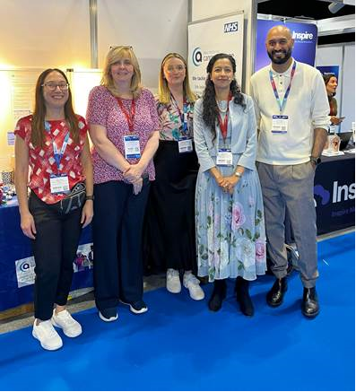  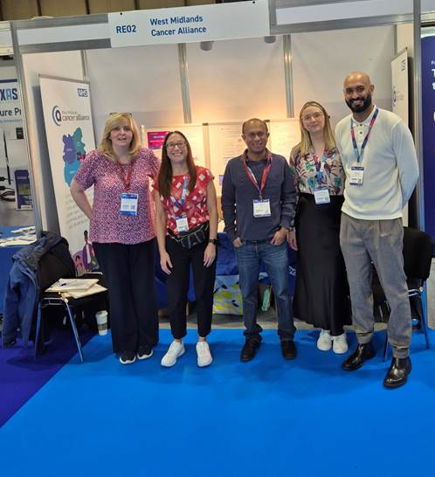  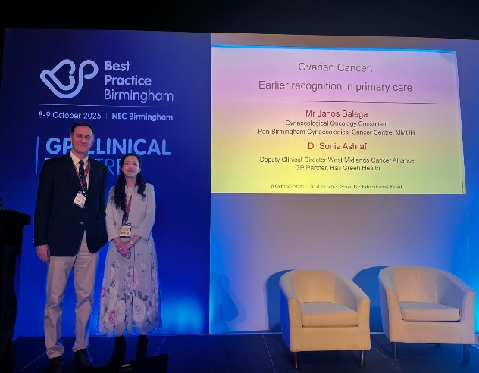
Introducing the Midlands Cancer Alliance Partnership Hub  A Midlands-wide collaboration to transform cancer care  West Midlands Cancer Alliance | East Midlands Cancer Alliance  We’re proud to announce the launch of the first Midlands-wide Cancer Alliance Partnership Hub — a landmark collaboration bringing together clinicians, system leaders, and life sciences industry partners to drive innovation and improvement across priority cancer pathways.  This initiative marks an exciting milestone in strengthening collaboration across the region. By sharing best practice, tackling shared challenges, and co-developing practical solutions, we aim to make a real difference for people affected by cancer across the Midlands.  Through open dialogue and partnership, the Hub will focus on accelerating progress in early diagnosis, treatment pathways, and patient experience, helping to deliver better, faster, and fairer outcomes for all.  As part of this work, we are exploring the creation of a new Life Sciences Innovation and Partnership Hub — a joint model for collaboration between industry and the NHS. This hub will focus on harnessing innovation to improve outcomes for patients and demonstrate measurable value for potential adoption and spread across the Midlands.  We are currently undertaking a discovery and learning exercise to shape our approach and ensure this partnership is designed to maximise impact and collaboration.  To support this, we have scheduled an online engagement event to share our progress and invite your insights:  🗓️ 3rd November, 11:00am – 12:30pm  Join us as we explore the opportunities ahead and work together to shape the future of cancer innovation and care across the Midlands.  Microsoft Virtual Events Powered by Teams |  | 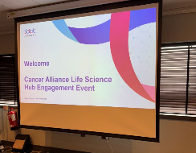  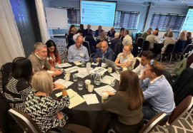  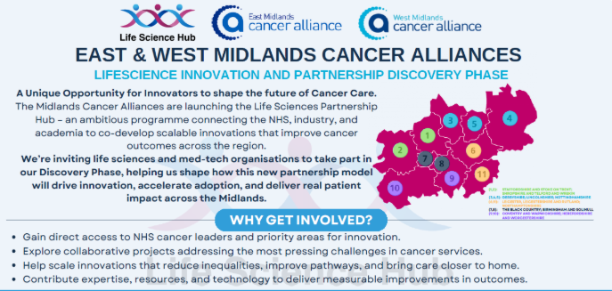
Participants in NHSE MDT Improvement Programme (cohort 2):
West Midlands Cancer Alliance is delighted to share that the second cohort of the NHS England (NHSE) MDT Improvement Programme will begin on Friday 3rd October, and we are proud that one of our regional MDTs will be taking part:
- University Hospitals Coventry and Warwickshire – HPB/NET MDT
This 18-week programme (including a short break over Christmas and New Year) is designed to empower MDTs to lead their own improvement work, supported by national best practice examples, action learning sets, peer discussions, and dedicated coaching from the NHS Cancer Programme or the NHS Elective Care Improvement Support Team.
We are pleased to see continued engagement from our region and look forward to supporting University Hospitals Coventry and Warwickshire as they embark on this improvement journey to enhance the effectiveness and quality of MDT working.
If you have any questions about the programme, please do reach out to us england.cmip@nhs.net

Standing Firm in Power and Pride  West Midlands Cancer Alliance partners with Prostate Cancer UK’s Black Health Equity Team  West Midlands Cancer Alliance is proud to be working in partnership with Prostate Cancer UK’s Black Health Equity Team to help address the inequalities that put Black men at greater risk of late prostate cancer diagnosis.  In the UK, 1 in 4 Black men will be diagnosed with prostate cancer — a stark reminder of the urgent need for greater awareness, earlier diagnosis, and equitable access to care.  Building on Prostate Cancer UK’s powerful outreach work — including their recent collaboration with the London Fire Brigade at Notting Hill Carnival — this partnership aims to extend that impact here in the West Midlands.  Together, we’re launching a new research project to better understand the barriers that prevent Black and Mixed Black men from being diagnosed earlier, when prostate cancer is most treatable.  We’re inviting Black and Mixed Black men from across the West Midlands to share their experiences — whether or not they have a prostate cancer diagnosis. Participants will be asked to complete a short survey, and may also be invited to take part in an interview or focus group. Those taking part in these sessions will receive a £50 voucher as a thank-you for their time.  This work sits at the heart of this year’s Black History Month theme, “Standing Firm in Power and Pride” — a celebration of resilience, strength, and progress. Together, we are standing firm to ensure that every man has the opportunity for earlier diagnosis, better treatment, and improved outcomes.  If you’re a Black or Mixed Black man living in the West Midlands — or know someone who is — we encourage you to get involved.  Contact Prostate UK Black Equity Health Team at BlackHealthEngagement@prostatecanceruk.org  to find out more or take part in the survey. |  | 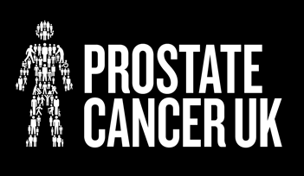
Black History Month Campaign Overview  Throughout October, the West Midlands Cancer Alliance marked Black History Month with a powerful four-week social media campaign focused on Black health equity and cancer awareness. We began by partnering with Prostate Cancer UK to spotlight the Black Health Equity Model, featuring Keith Morgan on why addressing inequalities in prostate cancer outcomes is so vital. Week two shared the inspiring story of Michael Lewis, whose early diagnosis and advocacy remind us of the importance of speaking openly about prostate cancer within our communities. In week three, we turned the focus to Black women and cancer, amplifying voices from Black Women Rising and sharing educational resources available through the Cancer Academy. Finally, week four highlighted the impact of community-led projects funded across the region, showcasing how grassroots organisations are helping to break down barriers, build trust, and drive meaningful change. Together, these stories and initiatives reinforced our shared commitment to tackling health inequalities and empowering Black communities to take charge of their health. |  | 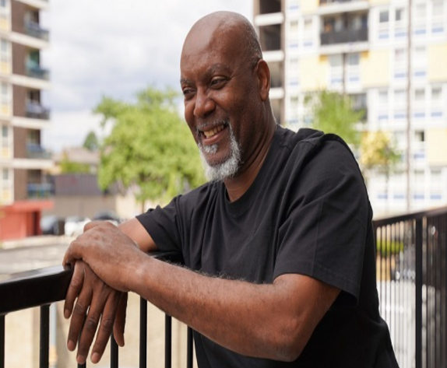
West Midlands Teenage and Young Adults Cancer Research Project
Teenagers and young adults with cancer (TYA) represent approximately 1% of the total cancer diagnoses in the UK each year, in the West Midlands this means 200 young people will be told they have cancer this year. Fortunately, TYA cancer is a rare cancer, but its rarity creates challenges.
Despite survival improvement in the more common malignancies cancer remains one of the main causes of death in the under 25-year-old. TYA cancer incidence is increasing and although the majority can be treated effectively, treatments are predominantly based on children and older adult research with minimal understanding of TYA response and toxicity.
Access to clinical trials, tumour banking and genomic testing is key to improving survival and experience for our young patients. The WM TYA Cancer Research Project is funded by WMCA and WM RRDN in recognition that young adults have restricted access to these options.
The West Midlands does not have a specialist TYA research/genomic workforce despite being a region with one of the largest populations of young adults with cancer in England. Regional adult and children’s research teams do an excellent job of recruiting TYA to clinical trials but without any specialist training or support.
As a result of the project the TYA Service have invited regional research teams, who care for TYA even if this is rarely, to attend Teenage Cancer Trust Communication Training, and this offer has been picked up by staff across the region.
Are you a children’s or adult cancer research or genomics nurse caring for patients aged 13-25?
Would you like to link into a regional network of peers? Accessing opportunities for education and updates on national initiatives? Please get in touch: donna.gillen@uhb.nhs.uk; tyaresearch@uhb.nhs.uk

For your information

CRUK Health System Update  New CRUK Report: Faster Diagnosis Standard (FDS)  NHS England has recently announced that it is changing the way that the Faster Diagnosis Standard (FDS) is being reported, to differentiate between patients who have cancer diagnosed or ruled out. We have worked with NHSE’s National Disease Registration Service to complete analysis that sheds light on patterns in FDS and illustrates the difference in FDS performance between these groups.  You can read our article here and the full report here.  Local CAM+ Update  Thank you to everyone who provided feedback on the proposal we circulated in July for the roll-out of the CAM+ survey on NHS regional footprints. We've begun preparations for data collection to be completed before Christmas and intend to deliver an analysis report for each region, comparing findings with the national position from the last CAM+ (Sept 2024) and, where sample sizes permit, with ICB-specific insights.  We will contact Alliances in early 2026 with further details on how we plan to share these reports.  Our new and updated resources for primary care  We have an array of new webpages for you to visit. See below:  - We’ve refreshed our safety netting webpages  - We've published our new non-specific symptoms (NSS) webpages. The guidance is broken down into 4 sections to be nation specific.  - We've updated our Faecal Immunochemical Test (FIT) information with a new FIT web hub.  - We've refreshed our bowel cancer screening good practice guide for primary care.  - We’ve updated our Lung and Urological cancer courses on GatewayC.  CRUK Article: 3 shifts to get risk stratification right for cancer  This summer CRUK convened academics, policymakers, clinicians, and health leaders to shape a view on how the forthcoming National Cancer Plan can support implementation of effective risk-stratification approaches for cancer.  You can read an article based on our findings here.  CRUK Article: The 10 Year Health Plan -What does it mean for cancer and the National Cancer Plan?  Matt Sample, CRUK's Senior Health Policy Manager, reflects on the implications for cancer policy of the 'three shifts' and actions set out in the 10 Year Health Plan, and what it means for the upcoming National Cancer Plan for England.  To find out more, you can find the article here.  Thank You to Our CRUK GPs: Marking the End of the Programme  As our CRUK GP Programme comes to a close on 30th September, we just want to say a final huge thank you to all of our CRUK GPs. We have really valued their input over the last 10 years to support with our education resources, influencing policy, and build a strong base of expertise that continues to guide our projects and engagement with the wider health system. |  | 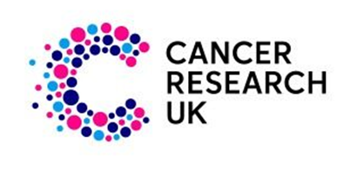
Cervical screening  Primary care good practice guide  This guide includes practical tips, information and signposting to resources for primary care  to support cervical screening activity. It aims to equip health professionals to encourage  informed choice to participate in cervical screening and address patient barriers to reduce  inequalities in uptake.  Cervical_Screening_Good_Practice_Guide.pdf |  | 
Upcoming events

Upcoming Expert Advisory Group (EAG) meetings  Expert Advisory Groups (EAGs) provide specialist advice and guidance to the WMCA board on the standards of cancer care for patient, reflecting ‘Improving Outcomes Guidance’ recommendations, current best practice and opportunities for development.  Please see the below details of upcoming EAG meetings:  Please note that these meetings are for EAG Members only.  For more information about joining these meetings, please email:  rwh-tr.wmcanceralliance@nhs.net.  *Please note that dates are correct at time of publication |  | 
  6th November 2025 | HPB EAG
  6th November 2025 | Breast EAG
  7th November 2025 | SACT EAG
  12th November 2025 | Primary Care EAG
  21st November 2025 | Head and Neck EAG
  26th November 2025 | Haematology EAG
  27th November 2025 | Psychosocial EAG
  27th November 2025 | Skin EAG
  27th November 2025 | Sarcoma EAG
  2nd December 2025 | MSCC AO & CUP EAG
  2nd December 2025 | Urology EAG
  4th December 2025 | Upper GI EAG
  9th December 2025 | EAG Chairs, Deputies & Clinical Pathway Leads EAG
  10th December 2025 | Colorectal EAG
  12th December 2025 | Radiotherapy EAG
Event for Cancer and Pain Professionals
The pain-related Complex Cancer Late Effects Rehabilitation Service team is excited to invite all healthcare professionals to our upcoming event on 20th March 2026 at the Apex Hotel, Bath.
The day will focus on:
• Understanding chronic pain as a cancer late effect
• Exploring the physical, emotional, and psychological impacts
• Hearing patient stories and real case studies
This is a great opportunity to learn, share experiences, and discuss strategies for supporting people living with persistent pain after cancer treatment.
Here are the links for the event. Please feel free to pass these on to colleagues who might be interested.
Ticket page:
Buy tickets – Chronic Pain as a Cancer Late Effect – Apex Hotel, 1 James Street, Bath

Development opportunities and additional learning

Check out our Cancer Academy  Our Cancer Academy is a centralised platform designed to support lifelong learning for our current, and future, cancer workforce. Designed for our entire cancer workforce, our courses and extensive resources are aimed at enhancing your knowledge and helping you stay skilled and up to date in all thing’s cancer care.  Upcoming training can be found here.  Octobers offer includes:  The ePortfolio, developed in partnership with the Greater Manchester Cancer Academy, is now available to the West Midlands Cancer Alliance workforce and it’s transforming how cancer professionals track, reflect, and showcase their development. Over 70 colleagues in the West Midlands have already signed up 🎉but we know there are hundreds more who could benefit. Don’t miss the chance to be part of a growing movement toward smarter, more empowered career development.  Your career deserves more than a paper trail. Start your ePortfolio today by accessing the WMCA Cancer Academy today and let your learning leave a legacy.  ePortfolio - West Midlands Cancer Alliance |  | 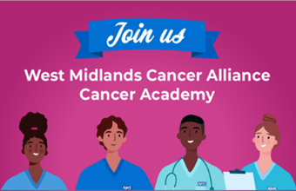
National Armed Forces Training and Education Programme (NAFTEP) developed by NHS England.  NHS Veterans Aware has launched a short introductory video for the new National Armed Forces Training and Education Programme (NAFTEP) developed by NHS England.  The initiative supports NHS staff in meeting the unique needs of the Armed Forces community, who may experience distinct health inequalities.  The training goes live on 6 November 2025 and includes flexible modules and national webinars. Staff can access the video and training details via the Veterans Covenant Healthcare Alliance website.  For queries, please contact Gemma Saunders, Regional Trainer at gemma.saunders12@nhs.net |  | 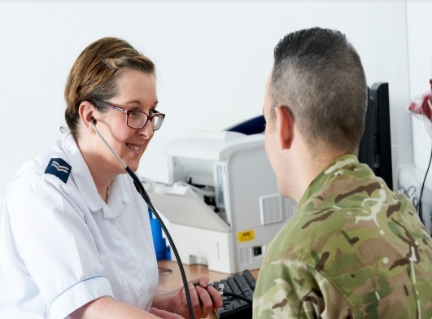
Vacancies

WMCA Expert Advisory Group (EAG) recruitment:
The West Midlands Cancer Alliance are currently recruiting to vacancies for a number of Expert Advisory Groups (EAG’s).

See the full list of vacancies here.

We are looking for candidates based on the following criteria:
- Ability to deliver national and regional work programme obligations.
- Demonstrable collaborative working with West Midlands Cancer Alliance.
- Experience with service change at scale.
- Credibility as a Cancer specialist in the West Midlands region.
- Regular attendance at EAGs or member of a Task and Finish group.
- Must be a current member of the West Midlands EAG group.

Candidates are asked to send their expressions of interest forms via email with accompanying CVs, stating why you would like to apply for this post, what you can bring to the post and your relevant experience for the role of Chair / Deputy Chair for the EAG to the following email: angela.gould1@nhs.net.
Readers Panel recruitment  We've created a Readers’ Panel, which is a group made up of Patient Advocates and members of the public who are passionate about improving cancer services across the West Midlands. These individuals volunteer their time to review draft patient information materials developed by WMCA and partner cancer services.  The purpose of the panel is to ensure that all written patient information, such as leaflets, appointment letters and service guides, is clear, accurate, accessible, and easy to understand from a patient or public perspective. The panel’s feedback plays a key role in helping us communicate more effectively with the people we serve.  Members of the Readers’ Panel will receive copies of draft information and be asked to review them before the materials are finalised and published.  We are looking for patients willing to contribute to the work of the WMCA and its partners, please contact us by filling in your details in the form below:  For more information contact Carolyn Parker, Project Improvement Manager - People and Community Engagement, at rwh-tr.wmcanceralliance@nhs.net |  | 
Patient and public voice (PPV) partner roles
Patient and public voice (PPV) partners play a crucial role in specialised services and are represented throughout our boards, committees and groups to ensure that the views of patients, carers and the public are at the heart of all we do.

We will be recruiting to the following PPV partner roles in coming weeks:
- Blood & Marrow Transplantation Clinical Reference Group (CRG)
- Child and Adolescent Mental Health Services (CAMHS) CRG
- Clinical Priorities Assurance Group (CPAG) - see details below
- Genomics Clinical Reference Group
- Haemoglobinopathies Clinical Reference Group
- Hepatobiliary and Pancreas Clinical Reference Group
- HIV Clinical Reference Group
- Individual Funding Request Panel
- Major Trauma and Burns Clinical Reference Group
- Rare Diseases Advisory Group (RDAG)
- Specialised Immunology and Allergy Services Clinical Reference Group
- Specialised Respiratory Clinical Reference Group

These roles will be advertised on this page NHS England » Specialised commissioning patient and public voice (PPV) partner roles

Please note that if you have previously held a particular role, you cannot reapply for that role, as per NHS England's PPV partner policy

The roles attract an involvement payment and expenses are covered.

CURRENT VACANCIES

Patient and Public Voice partner for Clinical Priorities Assurance Group (CPAG)

CPAG assesses medicines, medical devices and treatments according to their clinical effectiveness, benefit for patients and value for money. It considers recommendations from teams covering NHS England’s specialised commissioning responsibilities and detailed information about the financial impact.

Apply by 17 November 2025

Patient and Public Voice partner for hepatobiliary and pancreas Clinical Reference Group (CRG)

We are keen to hear from people who have lived experience of either serious complications of liver disease; biliary; or pancreatic disease; or experience of services for people with complex liver, biliary and pancreatic surgery; or are knowledgeable about these services and are connected in with patients.

Apply by 23 November 2025

Primary Care update

Explaining the Stokholm3 test for prostate cancer
The Stockholm3 test predicts a man’s risk of having csPCa in biopsy, based on a combination of plasma protein biomarkers (PSA, free PSA, hK2, MSMB, and MIC1), genetic markers, and clinical information. It is a blood-based diagnostic test that is to be used alongside prostate-specific antigen (PSA) testing to predict risk of prostate cancer in people aged 45 to 74 years with no previous prostate cancer diagnosis and uses an algorithm that combines plasma protein biomarkers, genetic markers, and clinical data and would be used in people with a PSA of at least 1.5 nanograms per ml.
The test uses 5 plasma protein markers (human glandular kallikrein 2 [hK2], microseminoprotein beta [MSMB],and the genetic markers include 101 single nucleotide polymorphisms, and the clinical data captured in the algorithm includes age, family history and previous prostate biopsy.
The Stockholm3 gives a score that indicates the risk of prostate cancer. A Stockholm3 risk score of at least 11% is considered an indicator of prostate cancer risk, and if it is used in primary care, these people would be referred to a hospital for an MRI (1).
Study evidence shows that the STHLM3-MRI trial found that combining the Stockholm3 (STHLM3) blood test reduced the number of biopsies needed while still accurately detecting clinically significant prostate cancer compared to traditional methods using only prostate-specific antigen (PSA) and systematic biopsies (2)
- compared with a PSA level of 3 nanograms per ml or higher, a Stockholm3 of 0.15 or higher provided identical sensitivity to detect clinically significant cancer and led to fewer MRI procedures (545 versus 846; 0.64) and fewer biopsy procedures (311 versus 338; 0.92)
- compared with screening using PSA and systematic biopsies, a Stockholm3 of 0.11 or higher combined with MRI-targeted and systematic biopsies was associated with higher detection of clinically significant cancers (227 [3.0%] people tested versus 106 [2.1%] people tested, lower detection of low-grade cancers (50 [0.7%] versus 73 [1.4%]), and led to fewer biopsy procedures.
  - the study authors stated that he Stockholm3 test can inform risk stratification before MRI and targeted biopsies in prostate cancer screening
    - combining the Stockholm3 test with an MRI-targeted biopsy approach for prostate cancer screening decreases overdetection while maintaining the ability to detect clinically significant cancer
- a study assessed the economic impact of using the Stockholm3 test in European health care systems using real-world evidence for diagnostic outcomes and relevant costs (3)
  - found that combining prostate-specific antigen (PSA) measurement with the Stockholm3 test in identifying candidates for magnetic resonance imaging in prostate cancer management could significantly reduce health care costs
  - combined strategy outperformed the traditional PSA diagnostic approach
  - cost reduction is primarily because of a decrease in costs related to metastatic prostate cancer

External newsletters

Please find a list of external newsletters you may be interested in accessing:
- Read the latest East Midlands Cancer Alliance (EMCA) newsletter here
- Read the West Midlands Imaging Network’s weekly round up here
- Read the Central and South Genomics newsletter here
- Request to join the Midlands Outpatient Transformation Programme workspace here
- Sign up to the West Midlands Radiotherapy Network’s quarterly newsletter here
- Sign up to Cancer Research UK’s Health Systems email updates here.

